**Basic Report Structure**

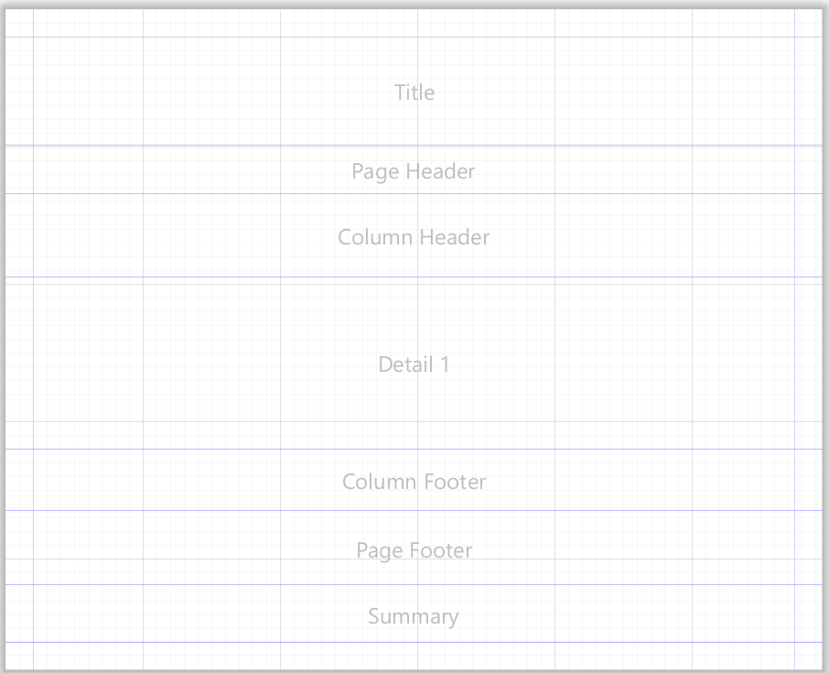

Figure - Report Structure

1. **Basic Report Structure**
   1. For each report there will be band that u will use in order to create the report based on the requirement given. Purpose of each band as below:
      1. Title – Mainly for the title of the report
      2. Page Header- For the header of the page for your report. Mostly the things that u want to display for every pages for your reports.
      3. Column Header – If u want to create table for your report then the table header must be in this band.
      4. Detail 1 – Detail is repeating data that u want to display. Let say u want to display a bundle of records then the field of data u need to put here.
      5. Column Footer -
      6. Page Footer - For the footer of the page for your report. Mostly the things that u want to display for every pages for your reports.
      7. Summary – For the summary of the reports. Let say u create a table then the last row u want to have the sum/average/counting of any related field, u will need to put the summary field at this band
2. **Dataset & Query**
   1. For the source of data (field) for your report, u need to add the query for the report at “DataSet & Query” editor dialog.
   2. Once u click the editor dialog, the dialog will be pop out and u can see the editor dialog.
   3. U need to insert your SQL at the right box and once u are done, click “Read Field” for the editor to check your query and extract all the field from your query.
   4. Please noted that u need to set the data adapter that u created earlier for the query to run.
   5. Once u are done u can have all the field to be use inside the report.
   6. U can refer figure below for reference.

Figure - Dataset & Query

Figure - Dataset & Query editor dialog

1. **Basic Elements & Composite Element**
   1. To create report basically u will use the element inside the basic elements tab.
   2. Most use basic element are:
      1. Text Field – For displaying the field from the SQL
      2. Static Text – Any text to display
      3. Sub-report – Sub-Report for main report, usually used when doing some complicated report that need 2 reports to be combine into one report
      4. Crosstab – For the purpose of displaying data that is dynamic by column and row. (Can refer example for further understanding)
      5. Table – For displaying data in table view (Can refer example for further understanding)
      6. Chart – For displaying chart data (Can refer example for further understanding)
   3. All of these somehow will be related to each other depending on how u want to create the report. As example for simple report u can just use Text Field and Static Text only but when u re presenting more information on the report. U can include chart and table in one report. Later, u will find out how all of these working.
   4. For Composite Element, is rarely used but u can just drag and drop to use the features. The composite element are:
      1. Page Number
      2. Total Page
      3. Current Date
      4. Time
      5. Percentage
      6. Page X of Y
   5. For composite element the functionality is the same as the name of the element itself. U can try to drag n drop to find out what they can do. Any element have their own super function depending on how u use it and where to implement it.

Figure - Basic Element & Composite Element Tab

1. **Properties**
   1. Properties is the place where u want to configure the Basic Element that are mentioned just now. All the things have their own properties. All the details will be explained below.
      1. **Text Field**

Figure - Text Field Properties

* + - * For **Text Field** properties u can see 6 tabs
        1. Appearance – To set on how the appearance for the text field. U can set the forecolour, backcolor, size and many things that involved the appearance of the Text Field.
        2. Borders – The best part of using Border is u didt have to create separate rectangle shape for the text field border. U just need to set the side of the border that u want and set the size of the border that needed.
        3. Text Field – U can set the expression for the text field. Expression here means which field from your SQL u want to display. U can set the font size, colour, text alignment and more.
        4. Inheritance – Rarely used.
        5. Hyperlink – U can set any site link for the hyperlink and the text field can be click and trigger to the link that u have set.
        6. Advanced – Rarely used but at this tab u can have a much more advances properties for the element.
    1. **Static Text**

Figure - Static Text Properties

* + - * For **Static Text** properties u can see 5 tabs
        1. Appearance – Same as Text Field properties. The tab allows u to set the forecolour, backcolor, size and many things that involved the appearance of the Static Text element.
        2. Borders – Same as Text Field properties.
        3. Static Text – Same as Text Field where u can set the text alignment, font size and more.
        4. Inheritance – Rarely used.
        5. Advanced - Rarely used but at this tab u can have a much more advances properties for the element.
    1. For the rest of properties element that frequently used will be explained more in their own “**Type of Report**” document. The rest are:
       - **Sub-Report**
       - **Crosstab**
       - **Table**
       - **Chart**

* + 1. Noted that **Text Field** and **Static Text** are most frequent used In any report or templates.

1. **3 Main Tab**

Figure - 3 Main Tab

* 1. For your information each report will have these 3 tabs –
     1. Design – The place where u have the main layout of the report and place all the elements in order to create one report.
     2. Source – The place where u can have the xml code for the reports. U can either edit the reports in code or by graphically. Depend on how u want to get your job done.
     3. Preview – The place you want to preview the report that u have design.
  2. Design

Figure - Design Tab

* + - * The place u put all the elements for your report design
  1. Source

Figure - Source Tab

* + - * The place where u can have the xml code for the reports. U can either edit the reports in code or by graphically. Depend on how u want to get your job done.
  1. Preview

Figure - Preview Tab

* + - * The The place you want to preview the report that u have design.

1. **Report Outline**
   1. Report outline is basically the structure of your report.

Figure - Report Outline

* 1. Report Outline Structure consist of:
     1. Styles – U can set your text field design here. It means that u just create one style and can implement on your all your text field. If you want to edit the style of the text field, u can just edit at the style and doest need to edit each one of the text fields.
     2. Parameters – For SQL that need input from user, u need to create the parameter to execute the SQL.
     3. Fields – All the fields extracted from the SQL will be listed here
     4. Sort Fields – Rarely use
     5. Variables – U can create Variables for any calculation such as sum, count, and average.
     6. Scriptlets – Rarely use
     7. Title – Place all the element inside **Title Band** here
     8. Page Header - Place all the element inside **Page Header Band** here
     9. Column Header - Place all the element inside **Column Header Band** here
     10. Detail 1 - Place all the element inside **Detail Band** here
     11. Column Footer - Place all the element inside **Column Footer Band** here
     12. Page Footer - Place all the element inside **Page Footer Band** here
     13. Last Page Footer - Place all the element inside **Last Page Footer Band** here
     14. Summary - Place all the element inside **Summary Band** here
     15. Background – Rarely use